Exercise 1: Control Structures

**Scenario 1:** The bank wants to apply a discount to loan interest rates for customers above 60 years old.

**Question:** Write a PL/SQL block that loops through all customers, checks their age, and if they are above 60, apply a 1% discount to their current loan interest rates.

**Code:**

-- Scenario 1: Apply 1% interest discount for customers above 60

BEGIN

FOR rec IN (SELECT customer_id FROM customers WHERE age > 60) LOOP

UPDATE loans

SET interest_rate = interest_rate - 1

WHERE customer_id = rec.customer_id;

END LOOP;

COMMIT;

END;

/

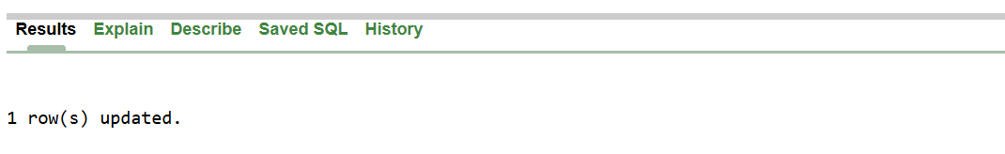

**Scenario 2:** A customer can be promoted to VIP status based on their balance.

**Question:** Write a PL/SQL block that iterates through all customers and sets a flag IsVIP to TRUE for those with a balance over $10,000.

**Code:**

-- Scenario 2: Promote customers to VIP if balance > $10,000

BEGIN

FOR rec IN (SELECT customer_id FROM customers WHERE balance > 10000) LOOP

UPDATE customers

SET isVIP = 'Y'

WHERE customer_id = rec.customer_id;

END LOOP;

COMMIT;

END;

/



**Scenario 3**: The bank wants to send reminders to customers whose loans are due within the next 30 days.

**Question**: Write a PL/SQL block that fetches all loans due in the next 30 days and prints a reminder message for each customer.

**Code:**

-- Scenario 3: Send reminders for loans due in next 30 days

BEGIN

FOR rec IN (

SELECT l.loan_id, c.name, l.due_date

FROM loans l

JOIN customers c ON l.customer_id = c.customer_id

WHERE l.due_date <= SYSDATE + 30

) LOOP

DBMS_OUTPUT.PUT_LINE('Reminder: ' || rec.name ||

' has loan ' || rec.loan_id ||

' due on ' || TO_CHAR(rec.due_date, 'DD-MON-YYYY'));

END LOOP;

END;

/

